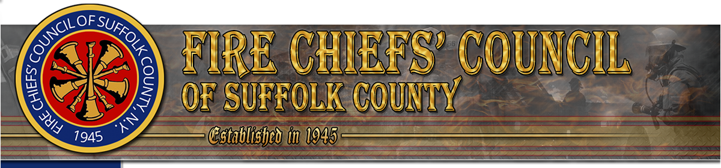

81ST
ANNIVERSARY
CELEBRATING OUR HISTORY

Sunday, November 22nd 2026
Brunch at Captain Bills
122 Ocean Avenue, Bayshore N.Y,
11:30 AM – 2:30 PM
$170 for two people

RSVP by Monday November 16th 2026
Rene49pow@yahoo.com
Check or Voucher to FCCSC, C/O Bodkin 80 Brook Street, West Sayville, NY 11796
DEPARTMENT______________# ATTENDING___
WE HOPE TO SEE YOU THERE!!

